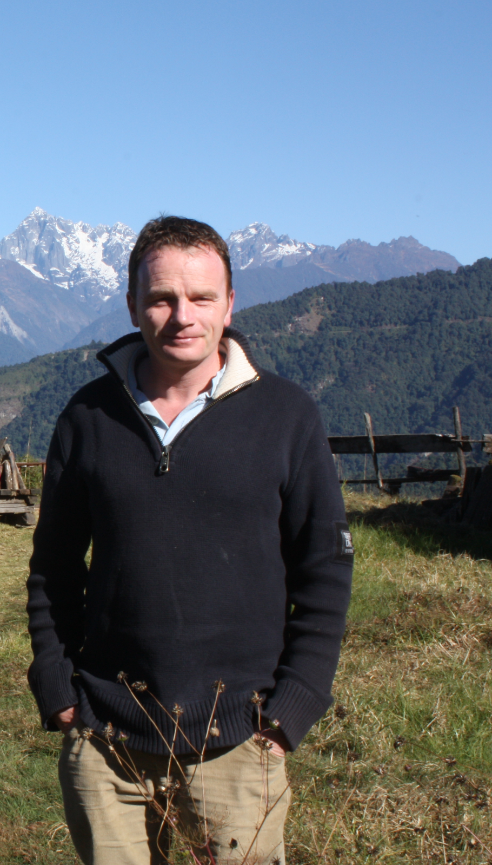

**Seamus O’Brien**

Seamus O’Brien is Head Gardener at the National Botanic Gardens, Kilmacurragh, Co. Wicklow, the country estate and rural annex of the National Botanic Gardens, Glasnevin in Dublin. He received his formal horticultural training at Glasnevin and also holds an International Diploma in Botanic Gardens Management from the Royal Botanic Gardens, Kew.

In the past he has been Head Gardener of several notable Irish gardens with historic plant collections, including Glanleam on Valentia Island, Co. Kerry famed for its southern hemisphere trees and shrubs, and Beech Park in Clonsilla, then renowned for one of the largest collections of herbaceous and alpine plants in Britain and Ireland. He returned to Glasnevin as a staff member in February 2000 and from there moved to manage the gardens at Kilmacurragh in May 2006.

He has travelled extensively across the globe to study plants in their native habitats, most notably to China, Nepal, Tibet, California, Bhutan, Myanmar, Chile, Australia, Tasmania, New Zealand, and, in more recent times to India, including successive trips to the Sikkim Himalaya. From these expeditions, he has published two award winning books; *In the Footsteps of Augustine Henry and his Chinese collectors* (2011), and, *In the Footsteps of Joseph Dalton Hooker: A Sikkim Adventure* (2018). He also contributes to several publications including *Curtis’s Botanical Magazine, The Irish Garden,* the Irish Garden Plant Society newsletter and the *International Dendrology Society Year Book.*

He lectures on garden history and botanical travel internationally and is a member of the Royal Horticultural Society’s Woody Plant Committee and is a judge of the RHS Early Spring Shows. Rhododendrons are a passion and he is Irish Branch Chairman of the Royal Horticultural Society’s Rhododendron Camellia and Magnolia Group. In 2018 Seamus was awarded the Royal Horticultural Society of Ireland’s Gold Medal of Honour, in 2021 he was made a Fellow of the Explorer’s Club (New York) and in 2022 he was awarded the Royal Horticultural Society’s (UK) Loder Rhododendron Cup.